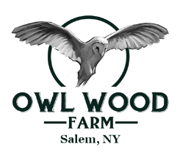
Owl Wood Farm CSA Membership Form
CSA stands for Community Supported Agriculture and is designed to connect the community directly with local farmers. Our CSA Program is a great way to support our small, local farm while getting the highest quality produce. The benefits of joining a CSA go both ways. By joining the Owl Wood Farm CSA members get a 10% discount on fresh, hand-picked, organically grown produce. By paying in advance, you help us guarantee that we will sell our produce and offset the high costs that we pay in the spring for seeds, equipment, compost, etc.
With our Market Share you can come to market whenever you want and get however much you want. The cost is a minimum of $200.
Our Boxed Share feeds a family of four or a vegetarian couple. It equates to $25-$30 worth of produce per week. If you are interested in becoming a member, please fill out the information below and return with a check to:
Owl Wood Farm, 10 Winters Way, Salem, NY 12865.
Thank you and we hope you enjoy the Season!
Name:_____________________________ Email:_____________________________
Phone #:___________________________ Address:___________________________
__________________________________
Market Share:______ (choose what you want at market, minimum $200 in increments of $100)
Boxed Summer Share: ______ $500 (starts 1st week in June, runs for 20 weeks)
Boxed Fall Share: ______ $200 (Starts mid-October, runs for 8 weeks)

Pick-Up Location:
*Saratoga Farmers Market: Wednesday____ Saturday____

*On-Farm Pickup: Wednesday After 1pm____ Saturday After 7am ____

Please note that shares are non-refundable and must be used by the end of the season. If you have any questions, don’t hesitate to contact us at owlwoodgrowers@gmail.com. We look forward to a great season!

